HOW TO MAKE ONLINE CONTACT WITH AN ARKIN PRACTITIONER
When you have an online appointment with an Arkin practitioner, you will receive an invitation in the mail to participate in an online conversation.
The invitation will include details about the appointment (the date and time) and a link that you can click on to start the online conversation. Below is an example of what this looks like in an email message.
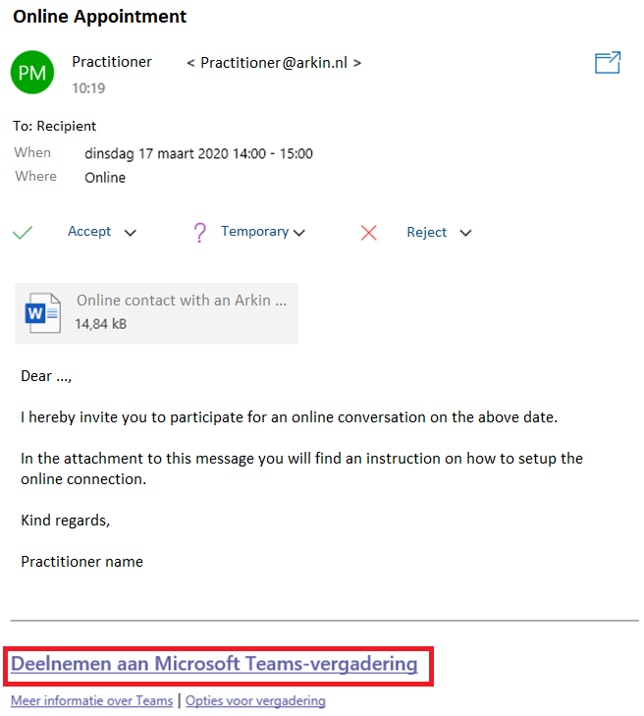 | Connect online through Microsoft Teams  To make contact online, perform the following steps:  1. Click on the ‘Deelname aan Microsoft Teams-vergadering’ link in the email message (or the appointment in your agenda)  Your web browser will now open. If you receive the message blow, first click on ‘Cancel’.  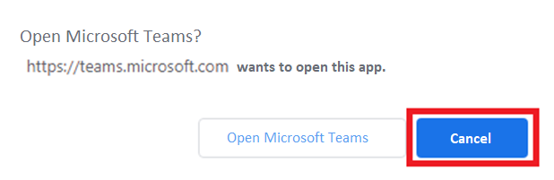
2. Then click ‘Participate on the web’  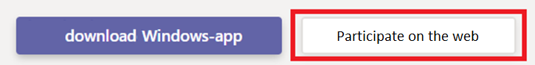 | 3. Enter your name and then click ‘Join Now’ to start the conversation  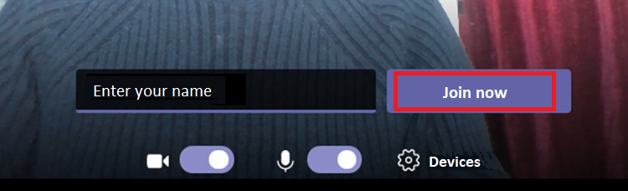
If you appear earlier in the appointment than the practitioner, you may have to wait a while until the practitioner allows you into the conversation. When the practitioner also appears in the conversation, you can see and hear him or her.

What do you need to enter an online conversation?
- A computer with a microphone and a camera (preferably, if you also want to share your image)
- A web browser where you can open Microsoft Teams (preferably Google Chrome or Microsoft Edge)
- A connection to the internet

