HOW TO MAKE ONLINE CONTACT WITH AN ARKIN PRACTITIONER WITH YOUR SMARTPHONE
When you have an online appointment with an Arkin practitioner, you will receive an invitation in the mail to participate in an online conversation. You can participate using your smartphone following this instruction.
1. Download the ‘Microsoft Teams’ app from the Apple App store or Google Play Store and install it. You don't need to open the app right away.  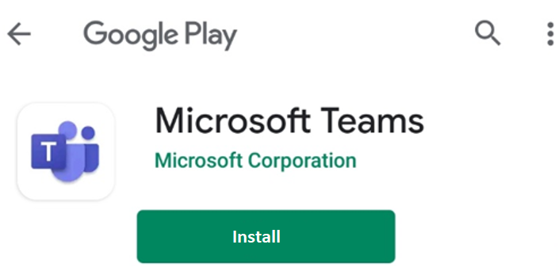 |  | 2. Click the ‘Deelname aan Microsoft Teams-vergadering’ link in the email message (or the appointment in your agenda)  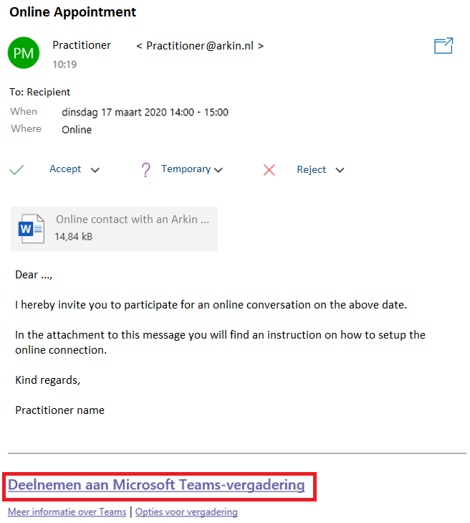
3. Click ‘Open with Teams’  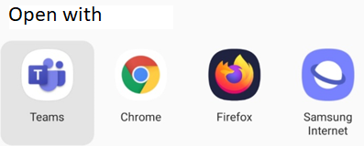 | 4. Click ‘Join as guest’  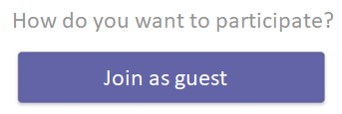 |  | 5. Enter your name and then click ‘Join as guest’ to start the conversation  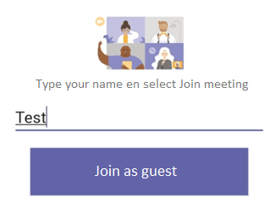
6. z Click ‘Allow’ to allow MS Teams to access your phone's audio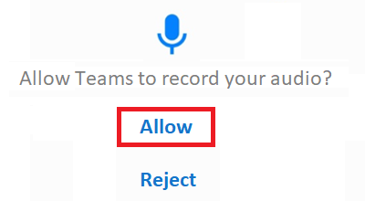  Conversations with your practitioner are never recorded! |  | 7. Connection is now being established. If you appear earlier in the appointment than the practitioner, you may have to wait a while until the practitioner allows you into the conversation. When the practitioner also appears in the conversation, you can see and hear him or her.  